Table of Contents

Created DC VM on Azure Cloud 2

RDP Connection to DC VM 3

Installation of ADDS, DHCP, and DNS 4

Disabled IPV6 and assigned static IP 6

Configuration of DHCP 7

Promoted DC to the Domain Controller and created a new forest 8

DHCP Scope creation and setup 10

Created DDC VM on Azure Cloud 12

RDP Connection to DDC VM 13

Disabled IPV6 and assigned static IP and set DNS to point towards DC’s private IP 13

DDC VM joining to “Dc.com” domain using DC’s credentials 14

Creation of Organizational Units 16

Creation of Users 17

Moved User (Citrix Admin) to “Admin Users” Organizational Unit. 19

Tested Users by logging into using DDC VM 20

Tested DNS by pinging Dc.com from DDC VM 22

# **Created DC VM on Azure Cloud**

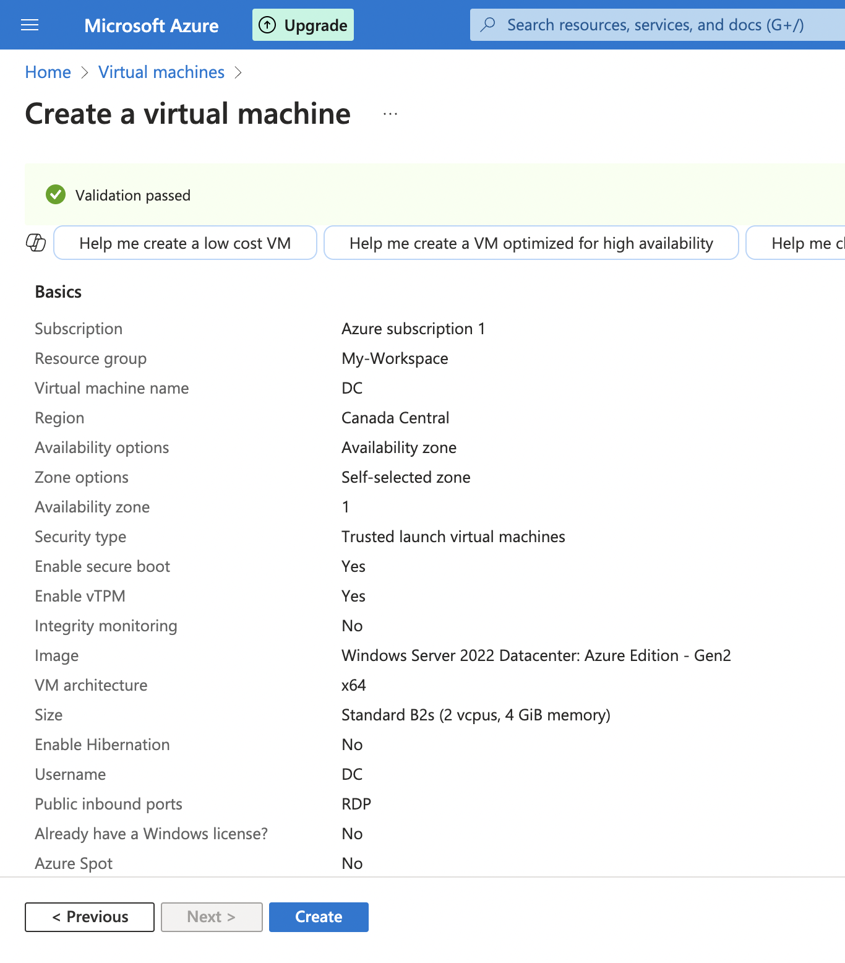

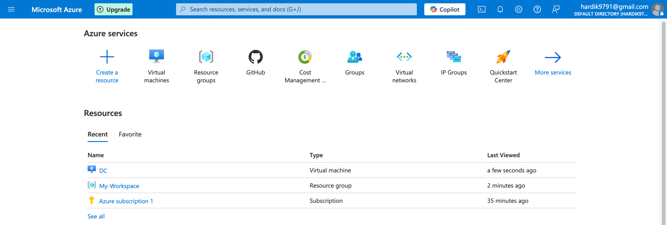

# **RDP Connection to DC VM**

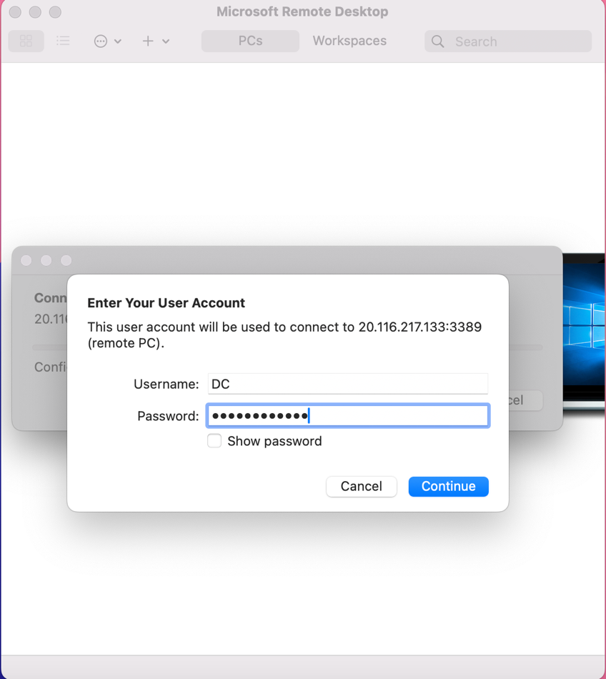

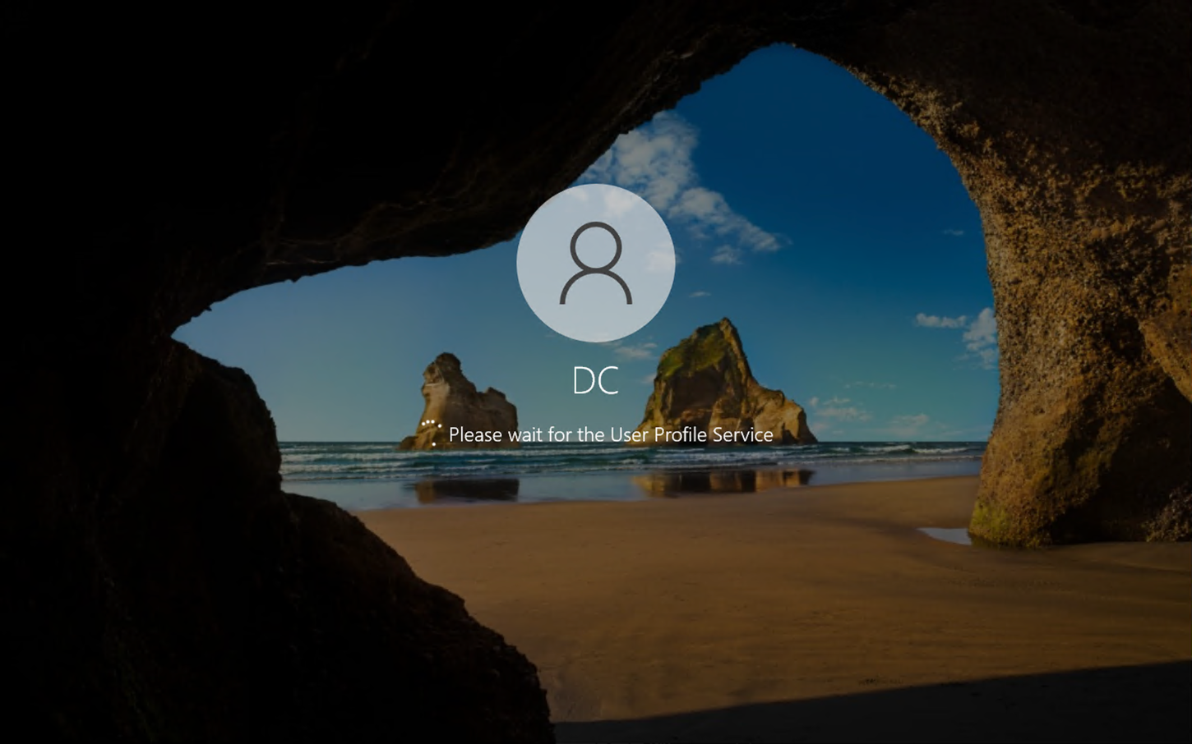

# **Disabled IPV6 and assigned static IP**

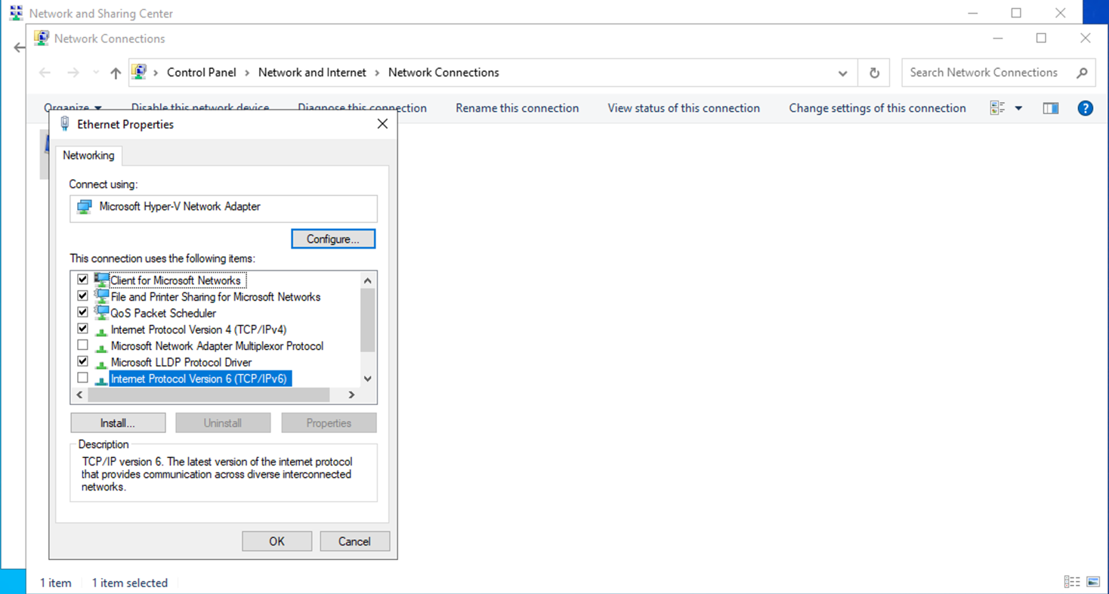

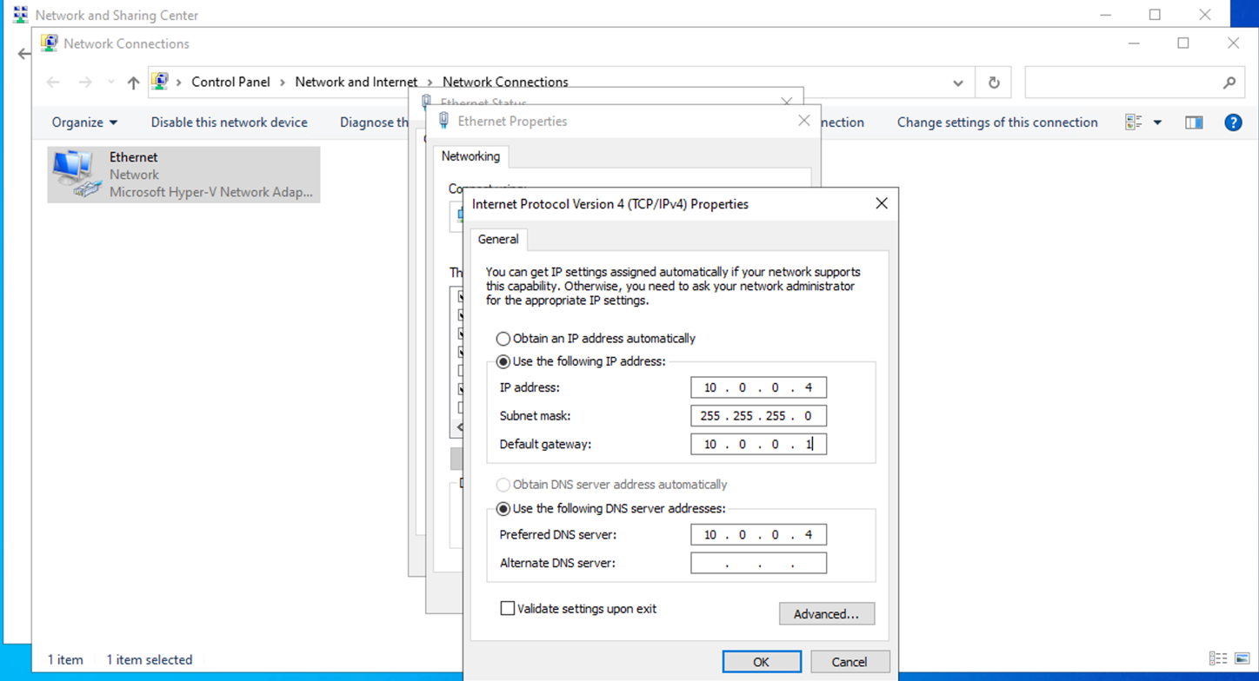

# **Installation of ADDS, DHCP, and DNS**

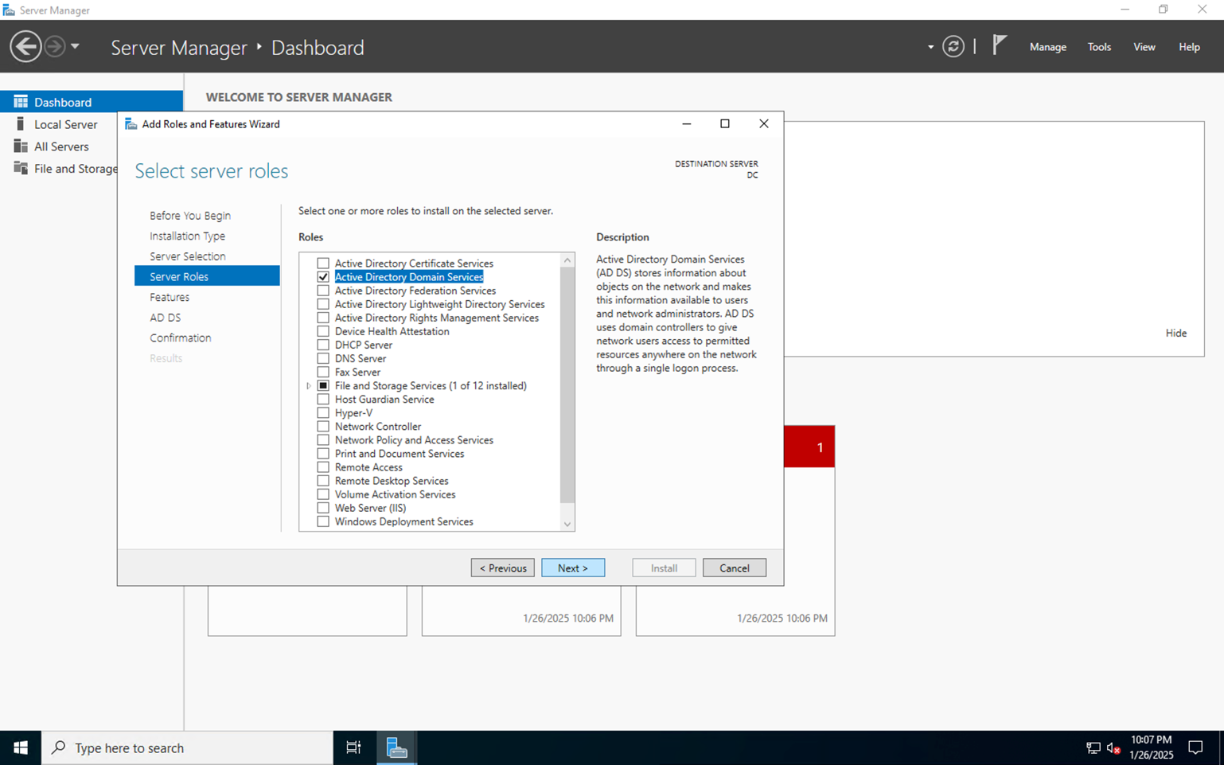

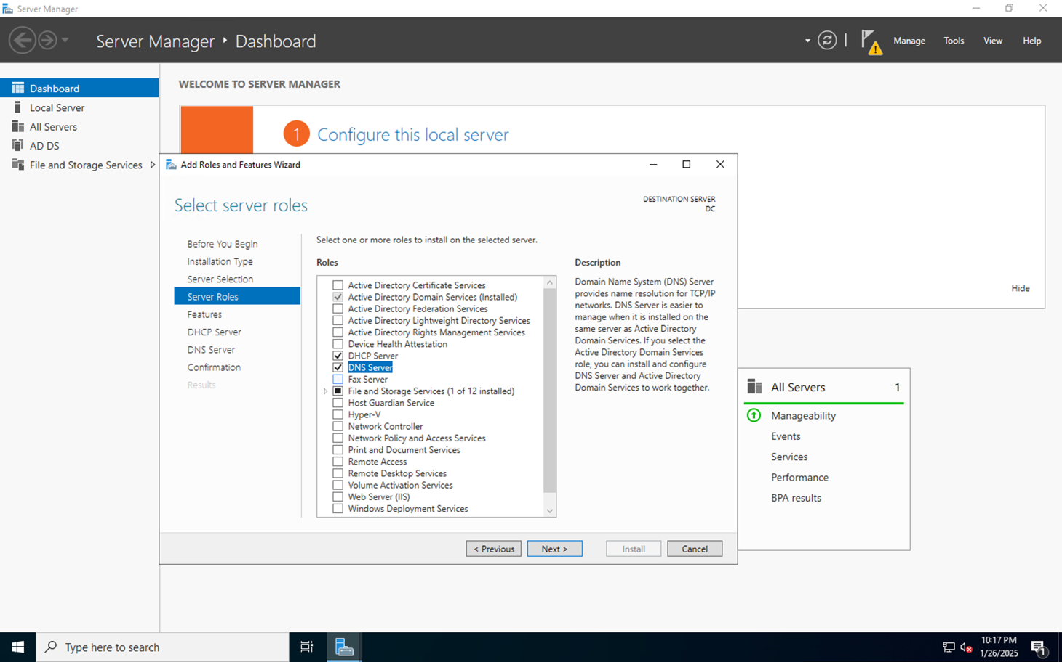

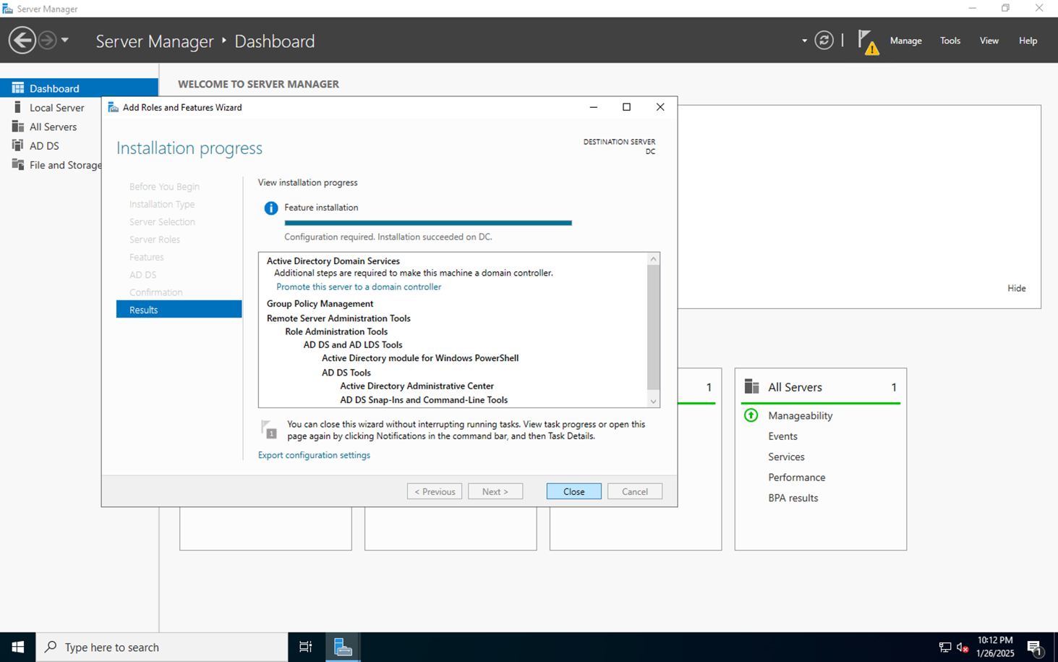

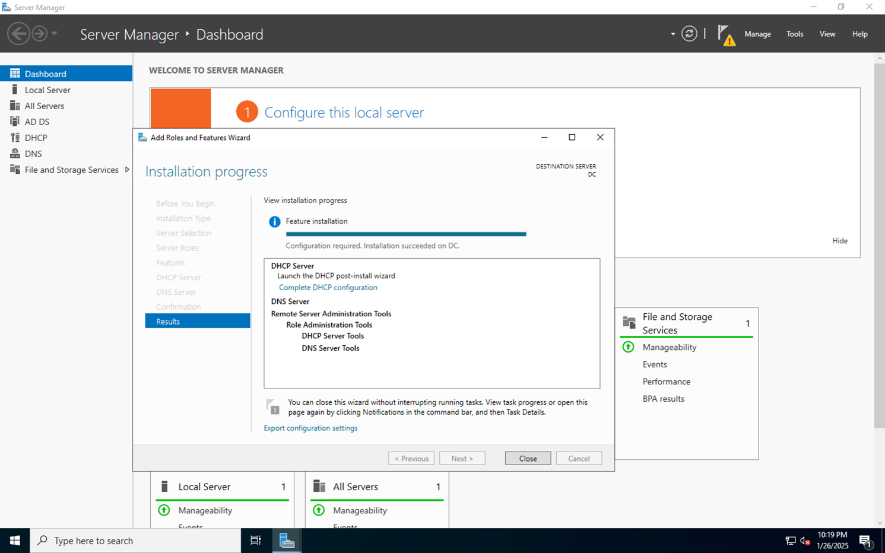

# **Configuration of DHCP**

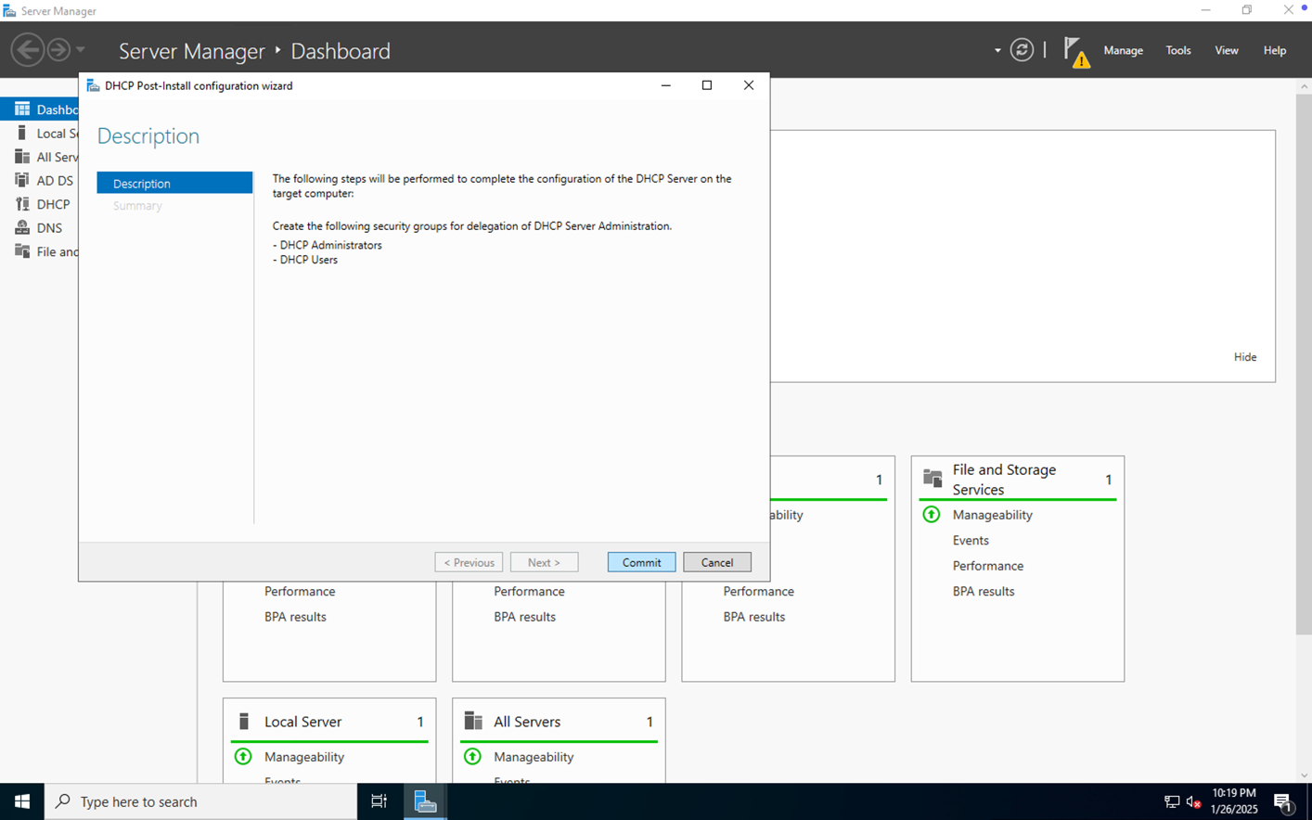

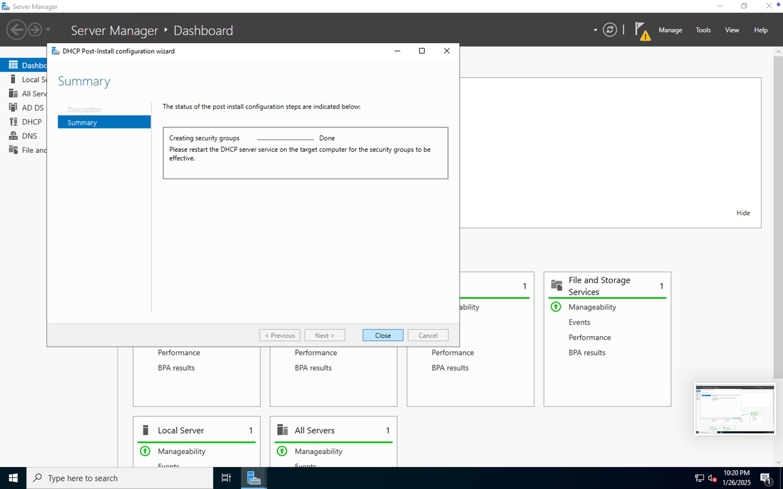

# **Promoted DC to the Domain Controller and created a new forest**

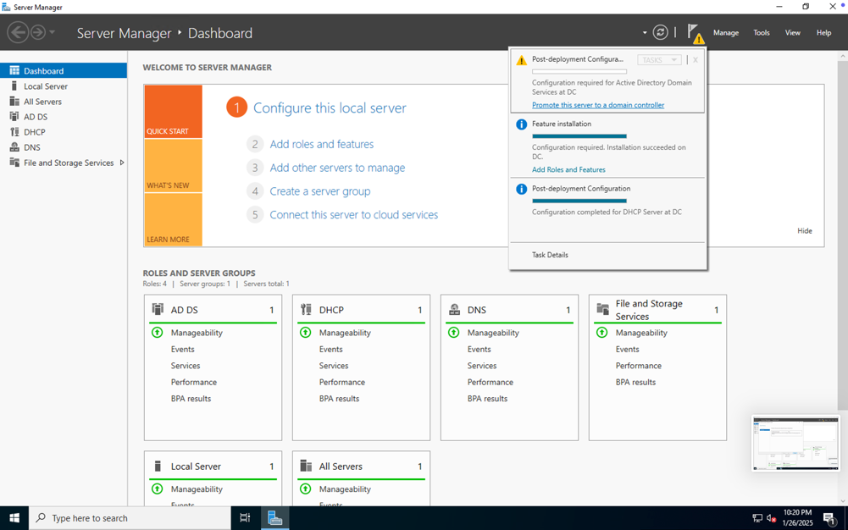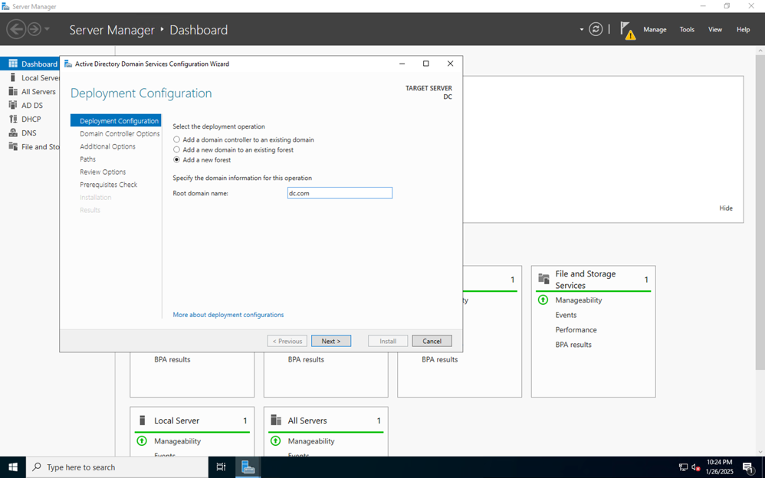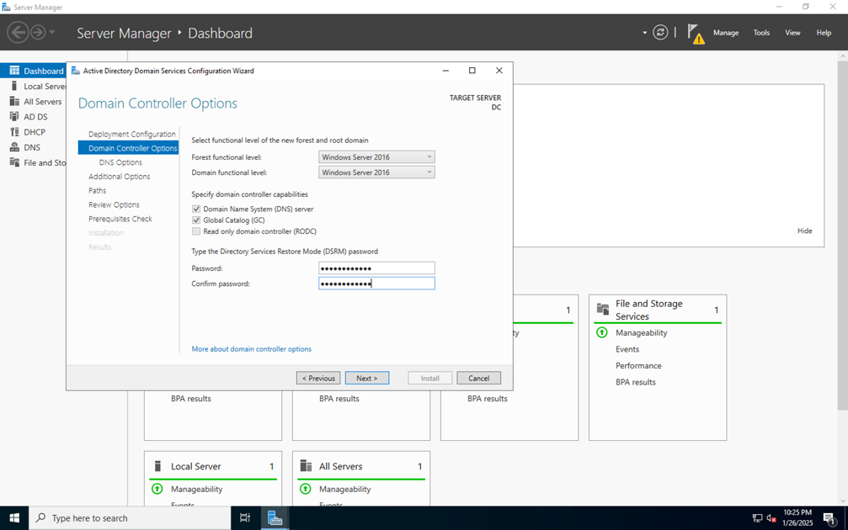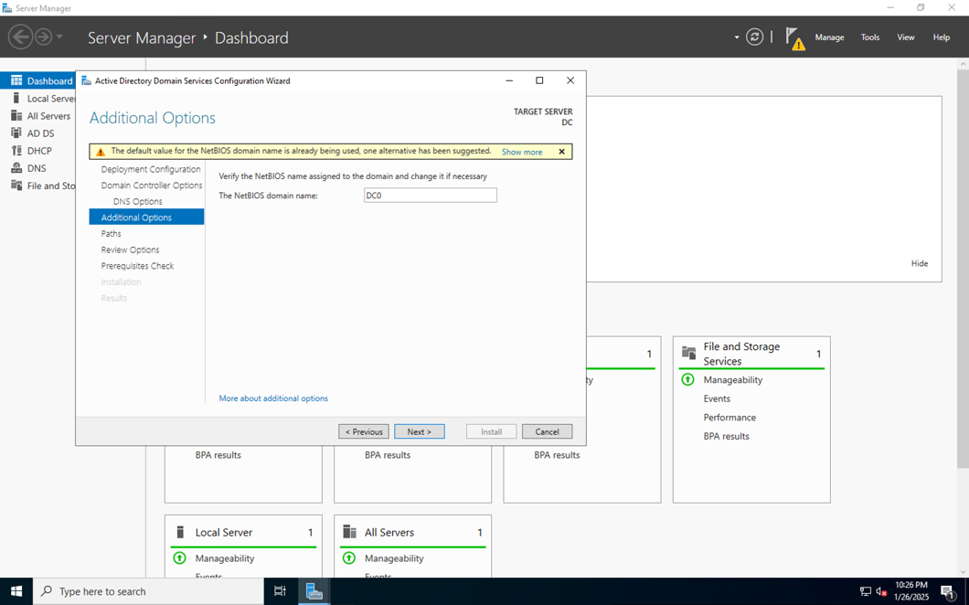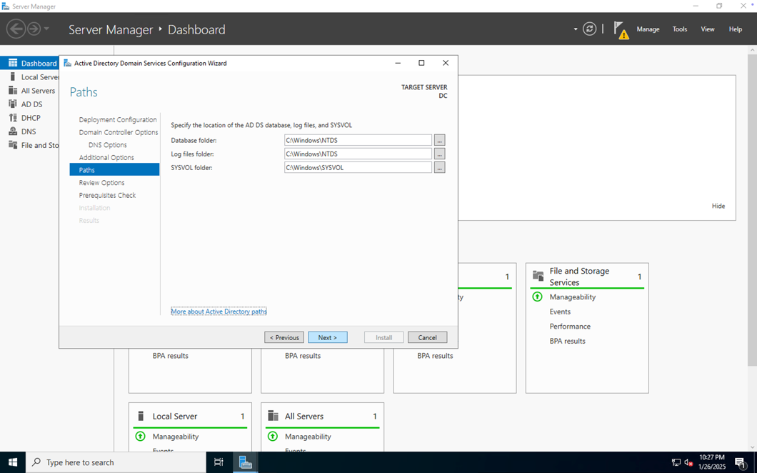

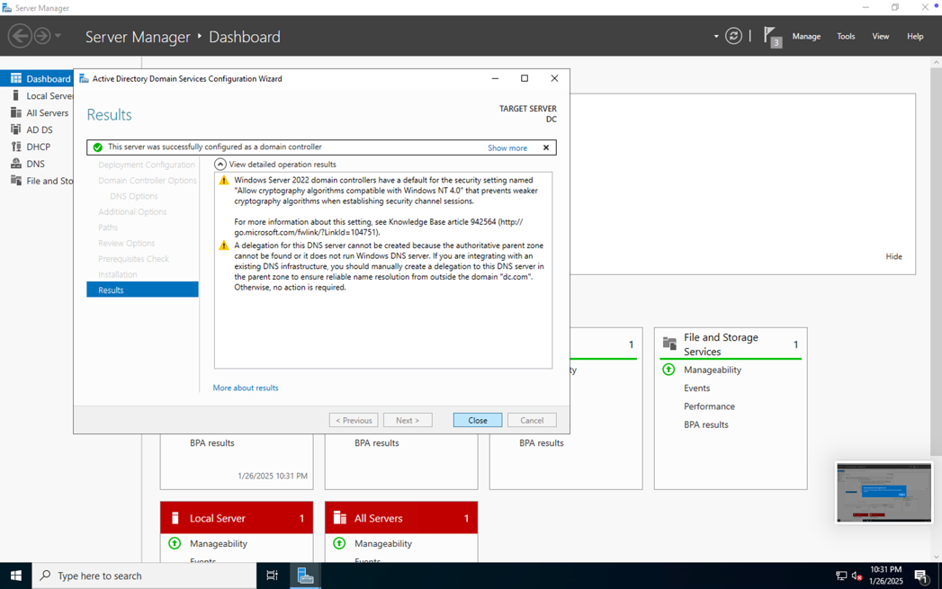

# **DHCP Scope creation and setup**

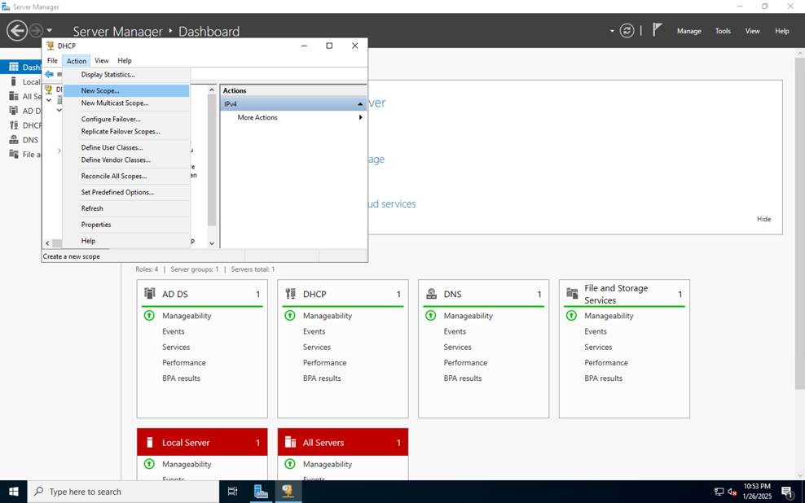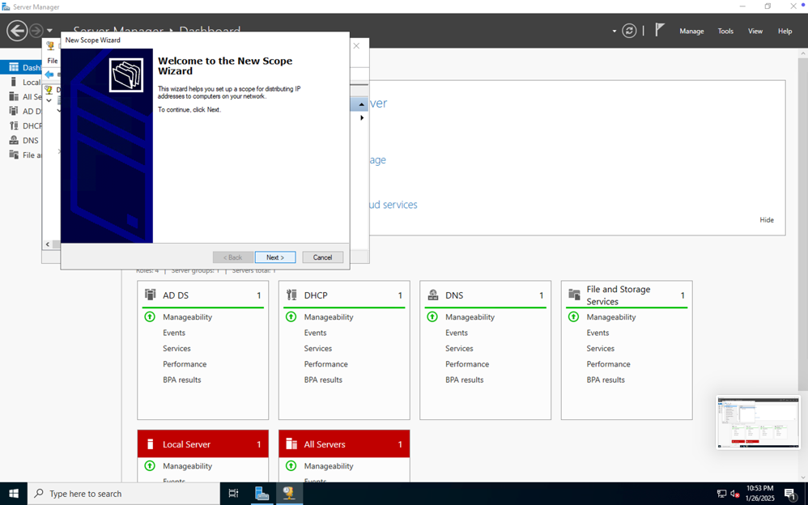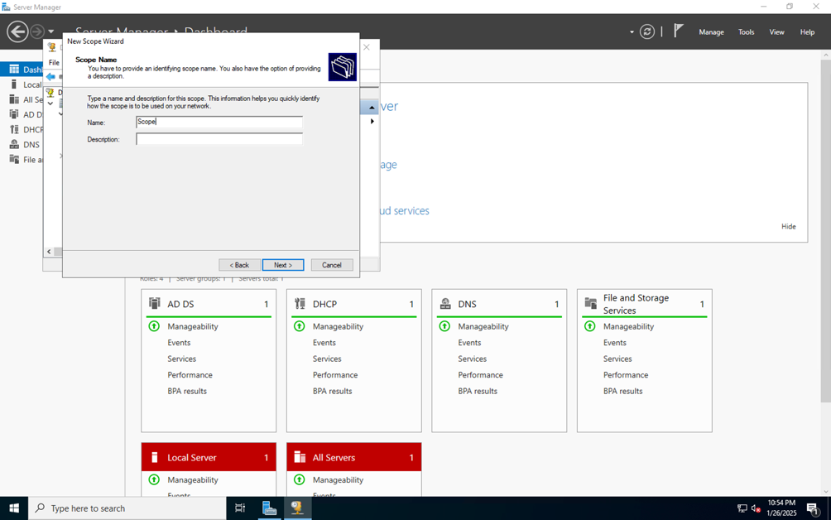

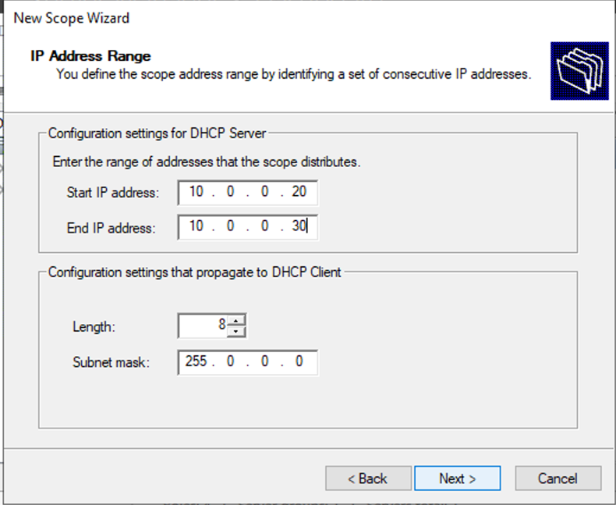

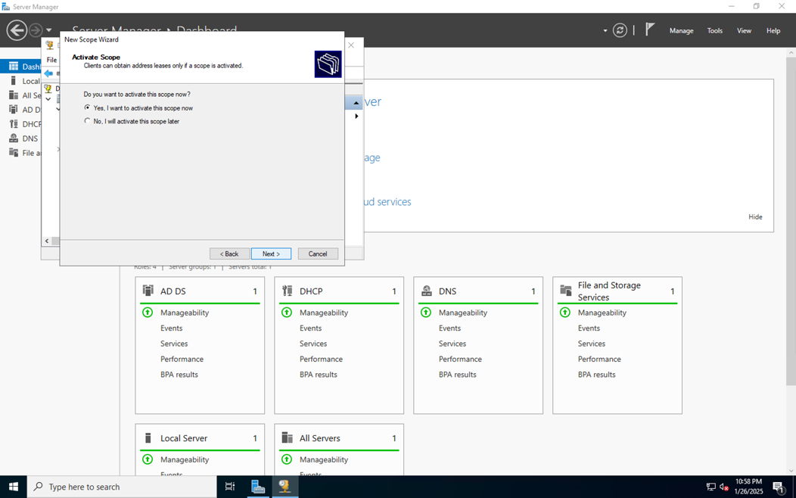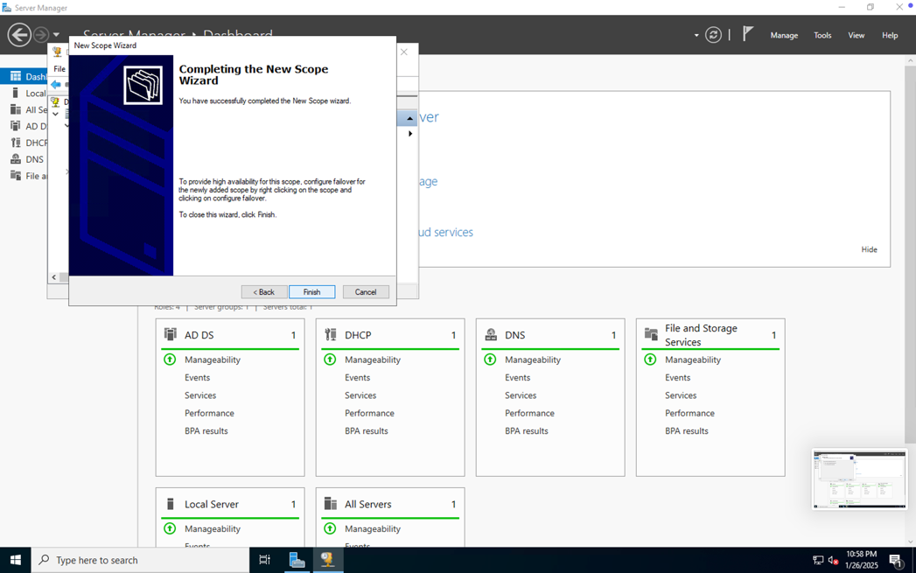

# **Created DDC VM on Azure Cloud**

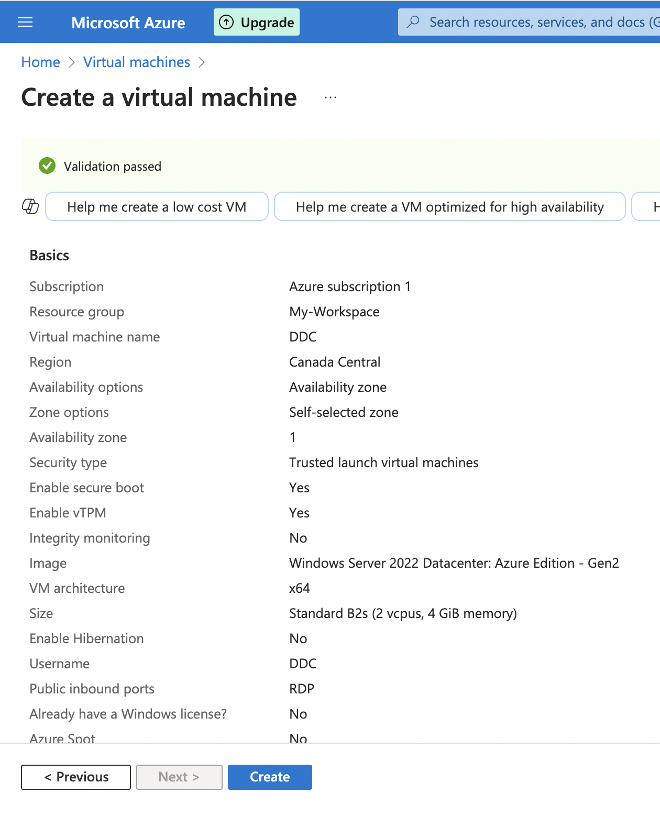

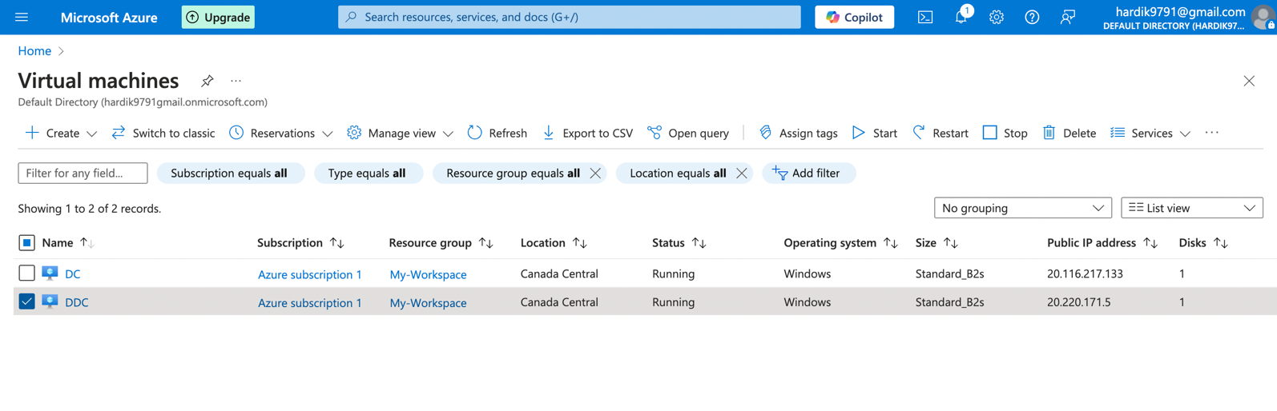

# **RDP Connection to DDC VM**

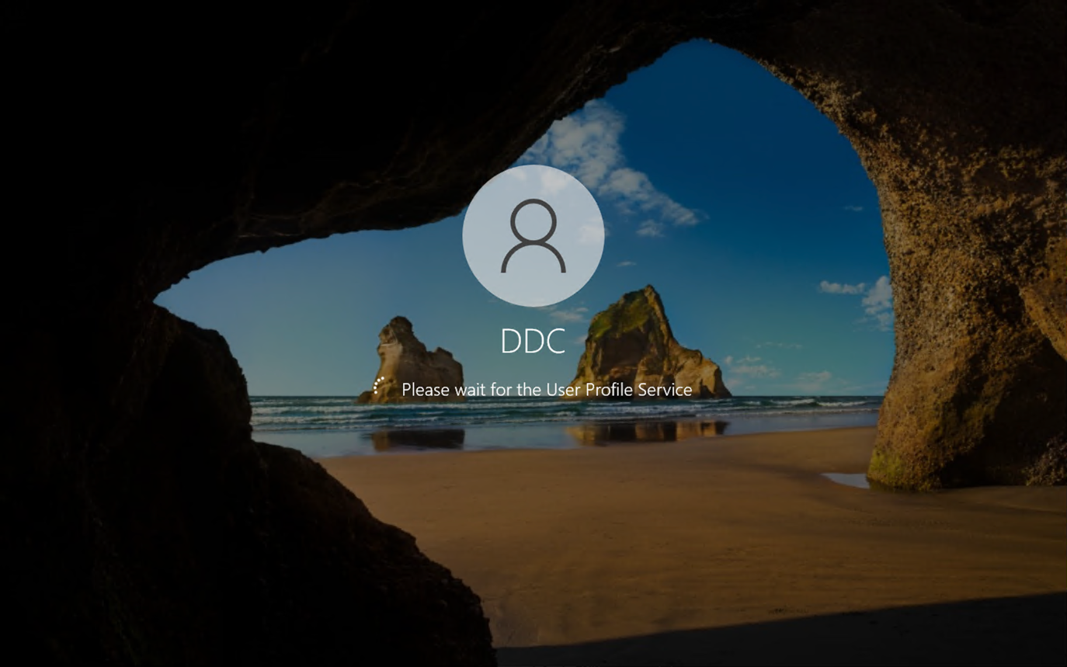

# **Disabled IPV6 and assigned static IP and set DNS to point towards DC’s private IP**

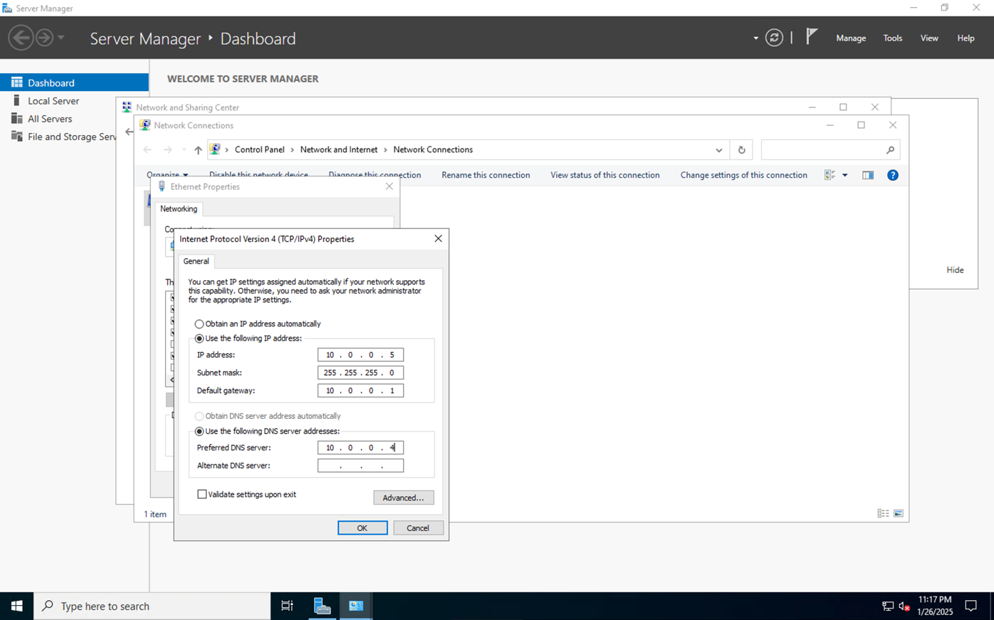

# **DDC VM joining to “Dc.com” domain using DC’s credentials**

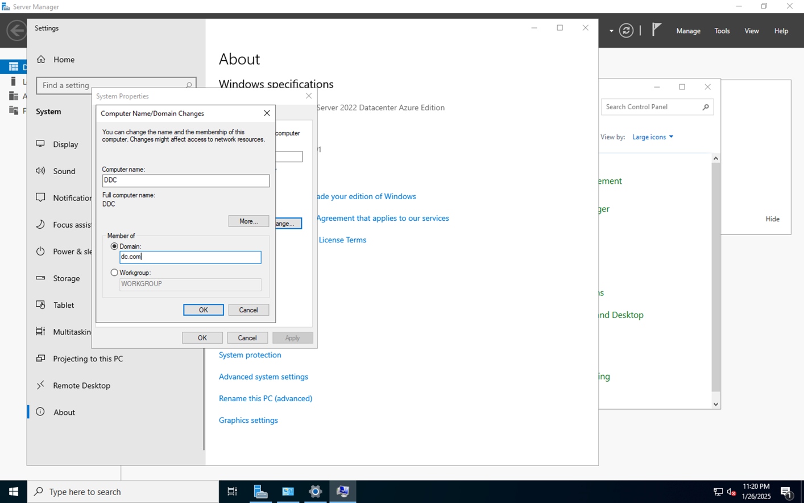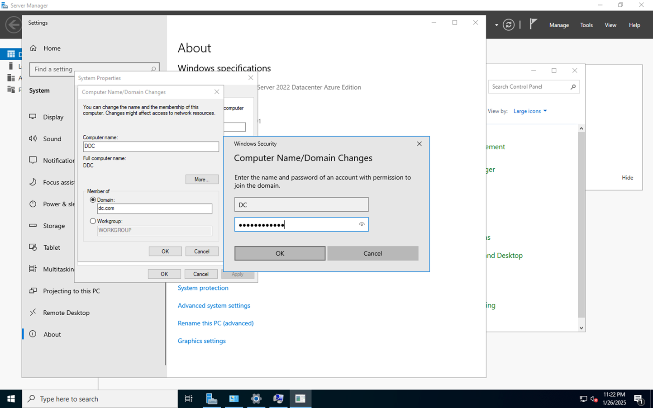

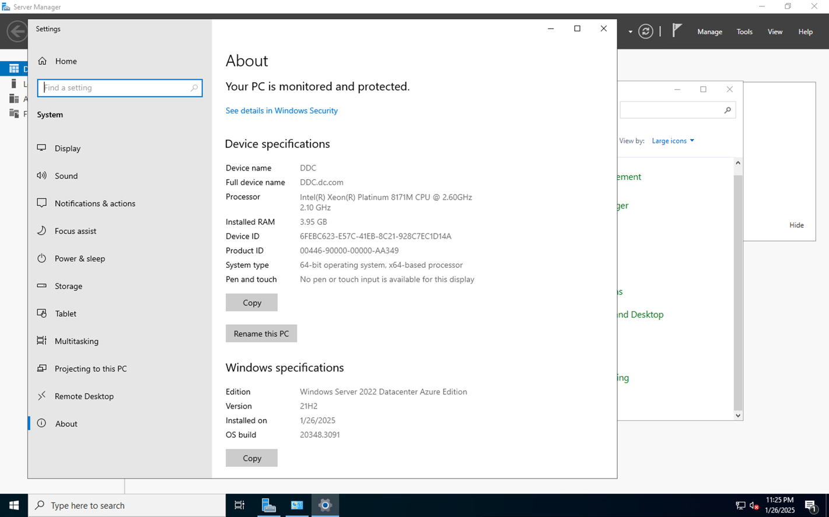

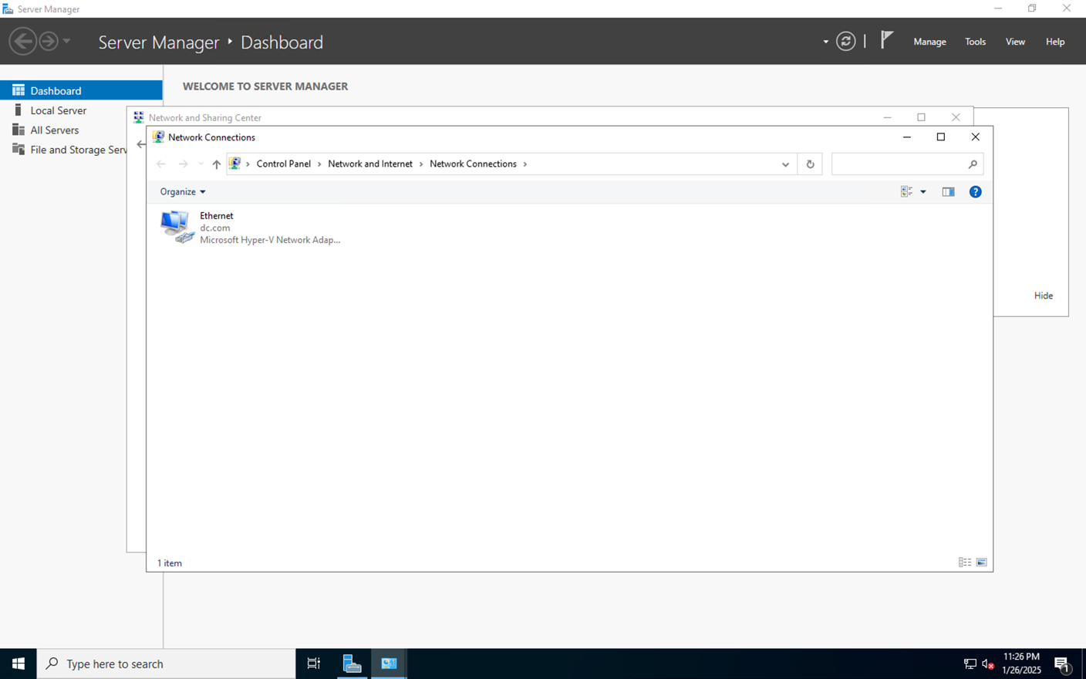

# **Creation of Organizational Units**

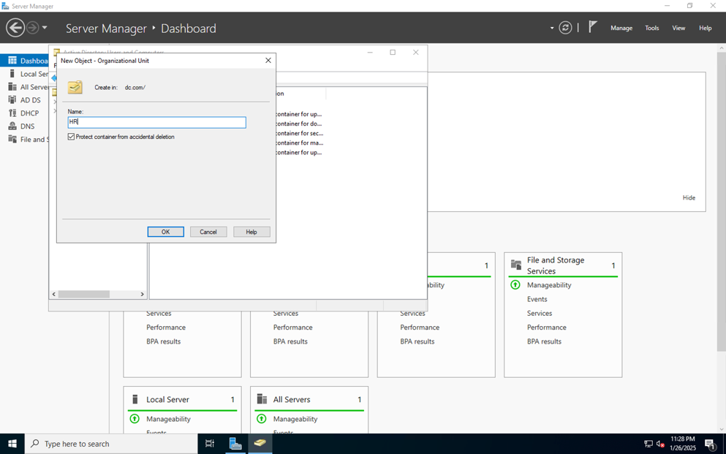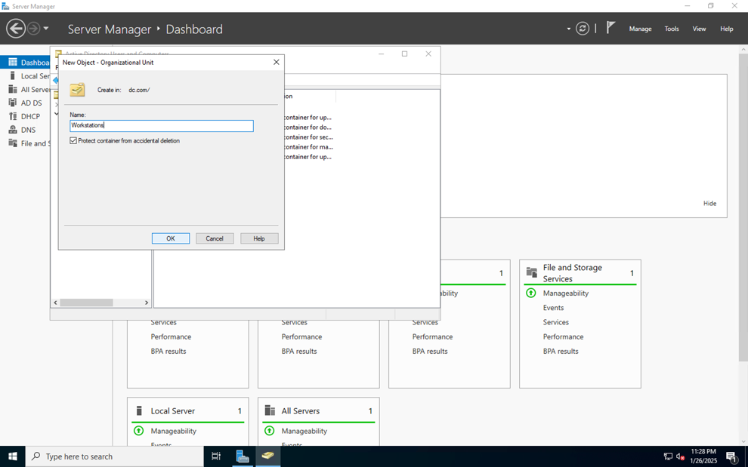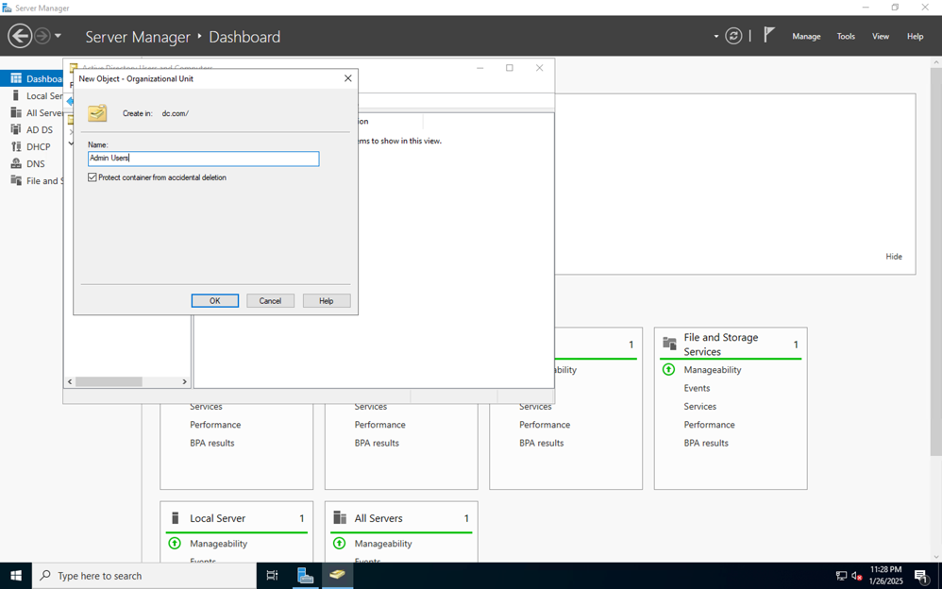

# **Creation of Users**

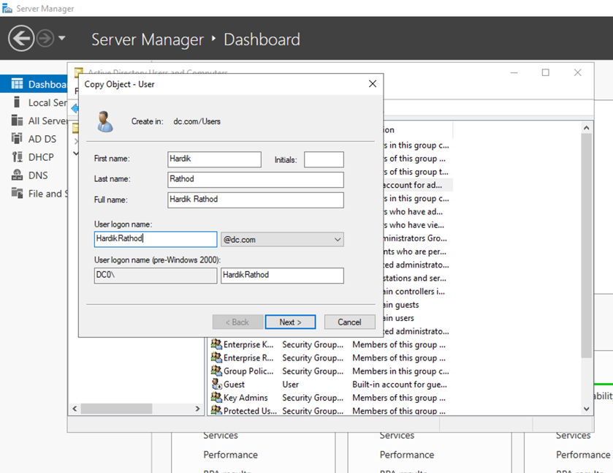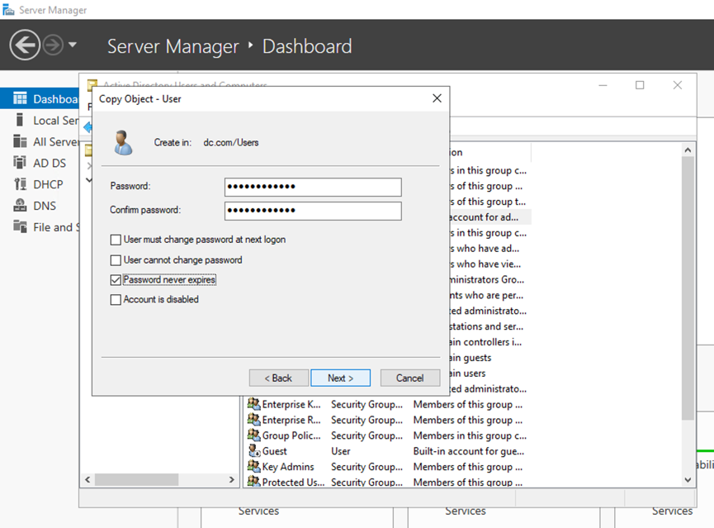

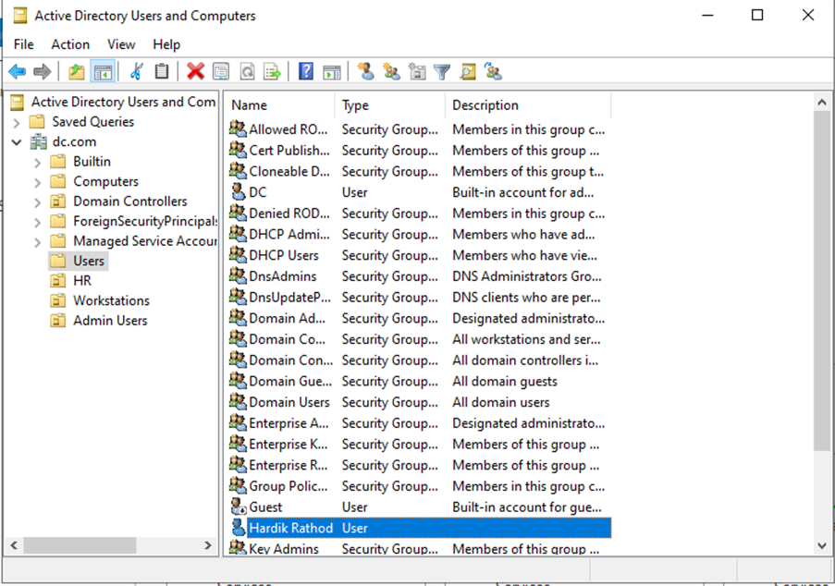

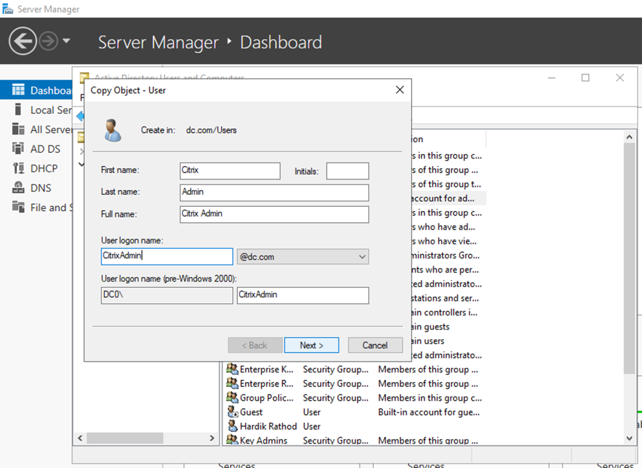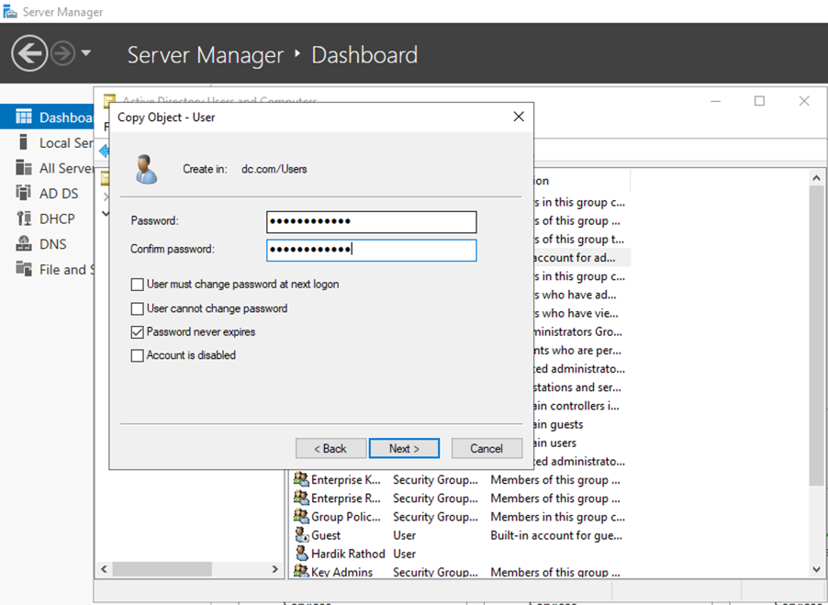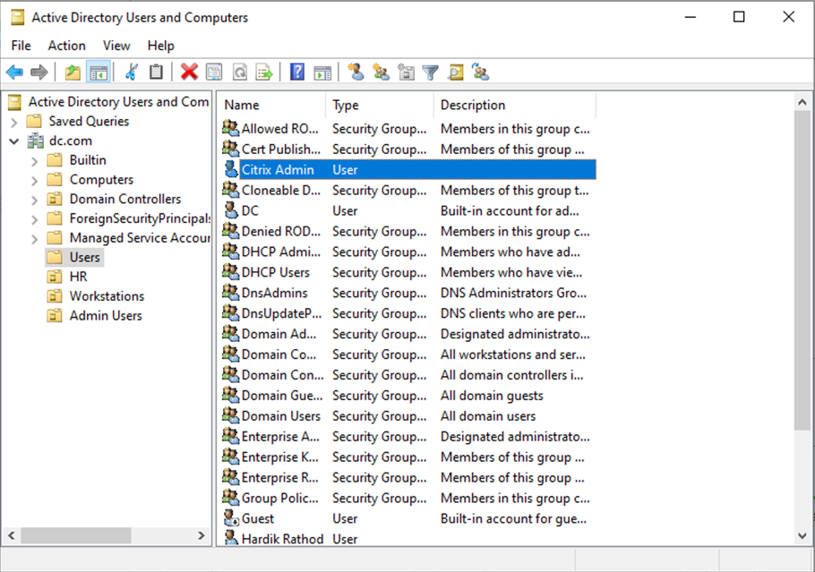

# **Moved User (Citrix Admin) to “Admin Users” Organizational Unit.**

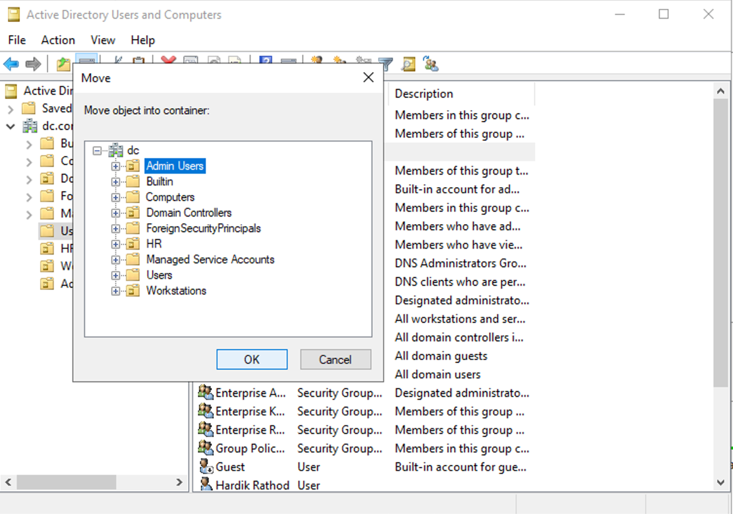

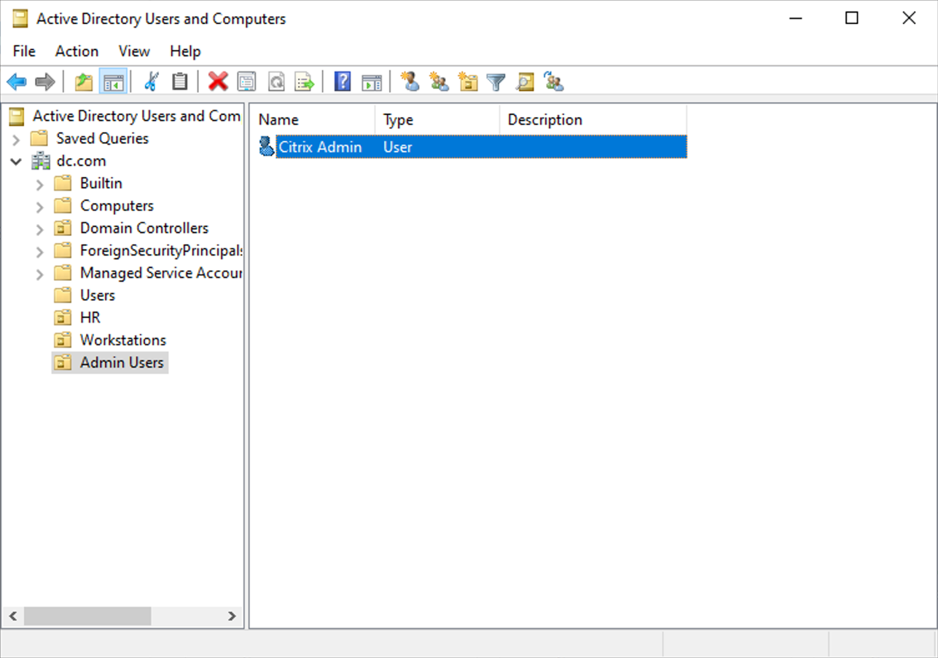

# **Tested Users by logging into using DDC VM**

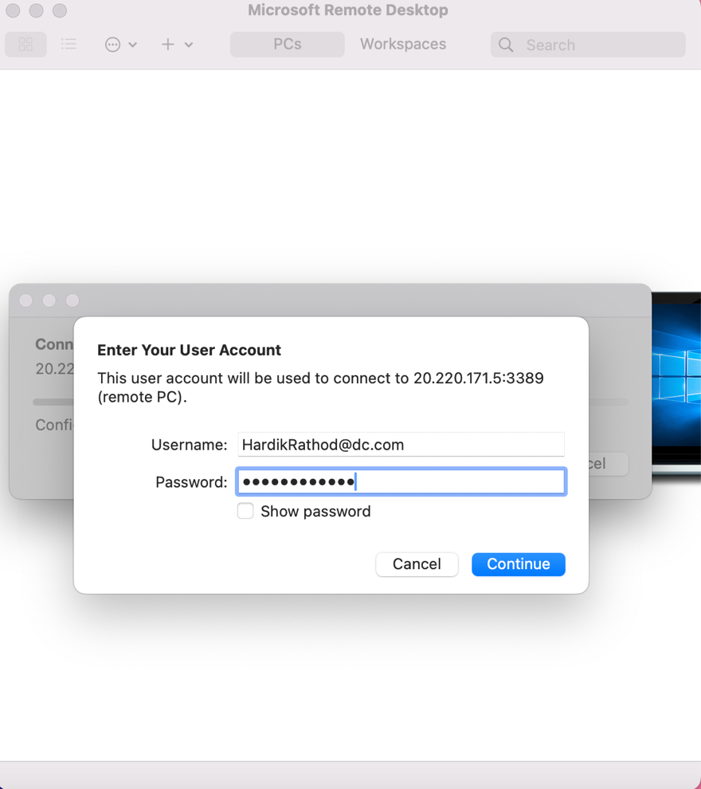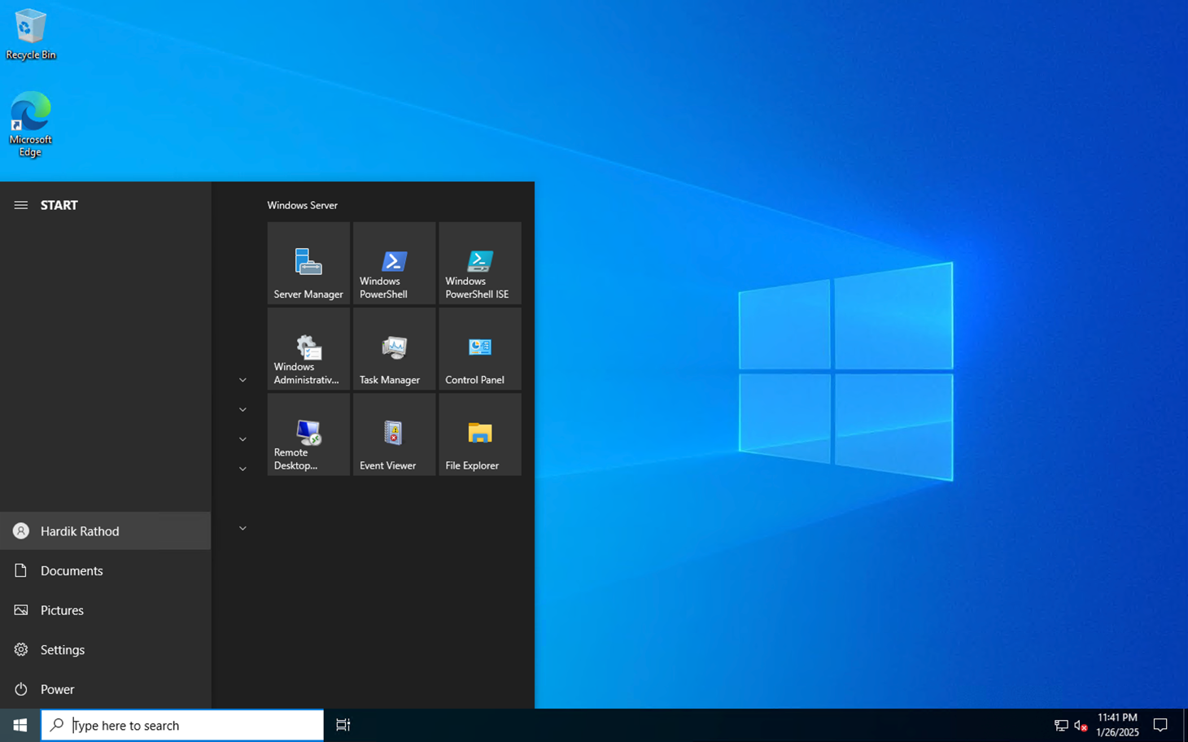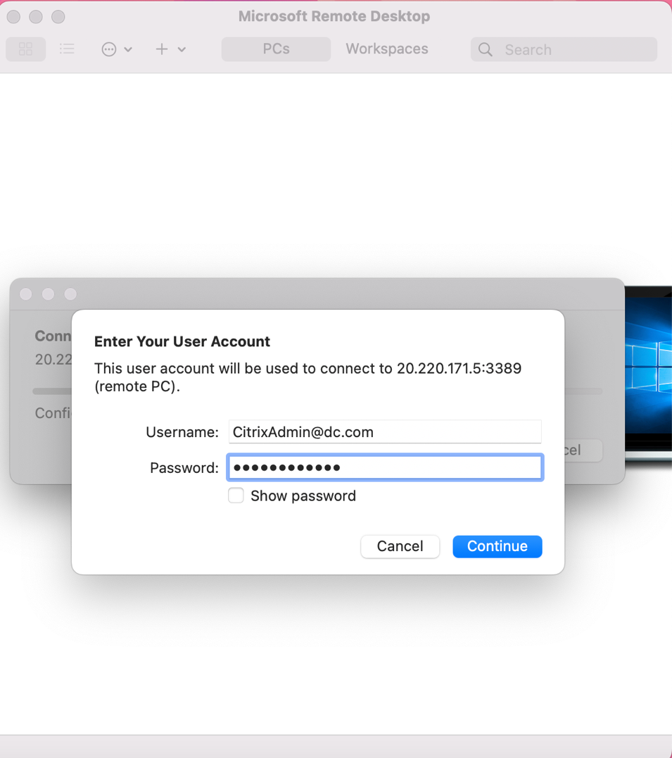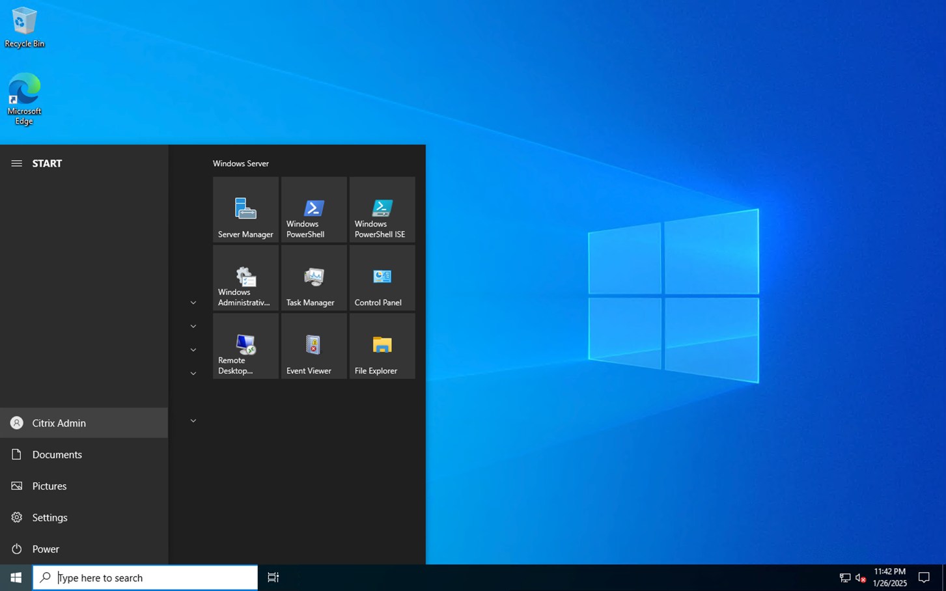

# **Tested DNS by pinging Dc.com from DDC VM**

